DATA ANALYTICS WITH TABLEAU ASSIGNMENT -2

P. Baby Vineela

VNITSW

4th B.Tech (CSE)

20NN1A05G7

● Donut Chart

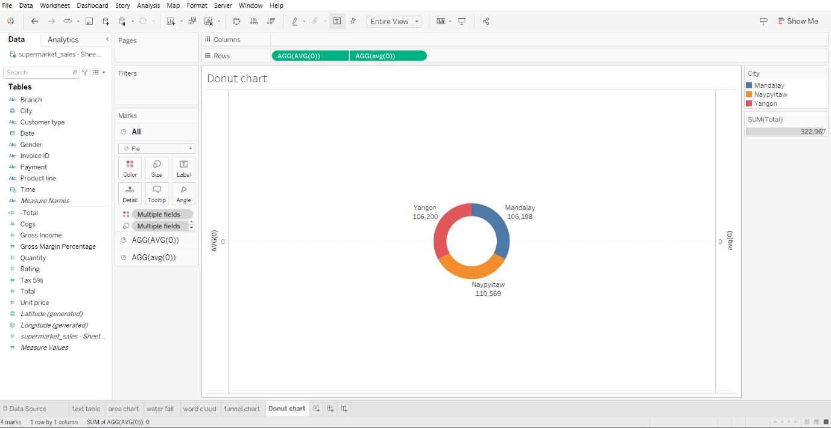

● Area Chart

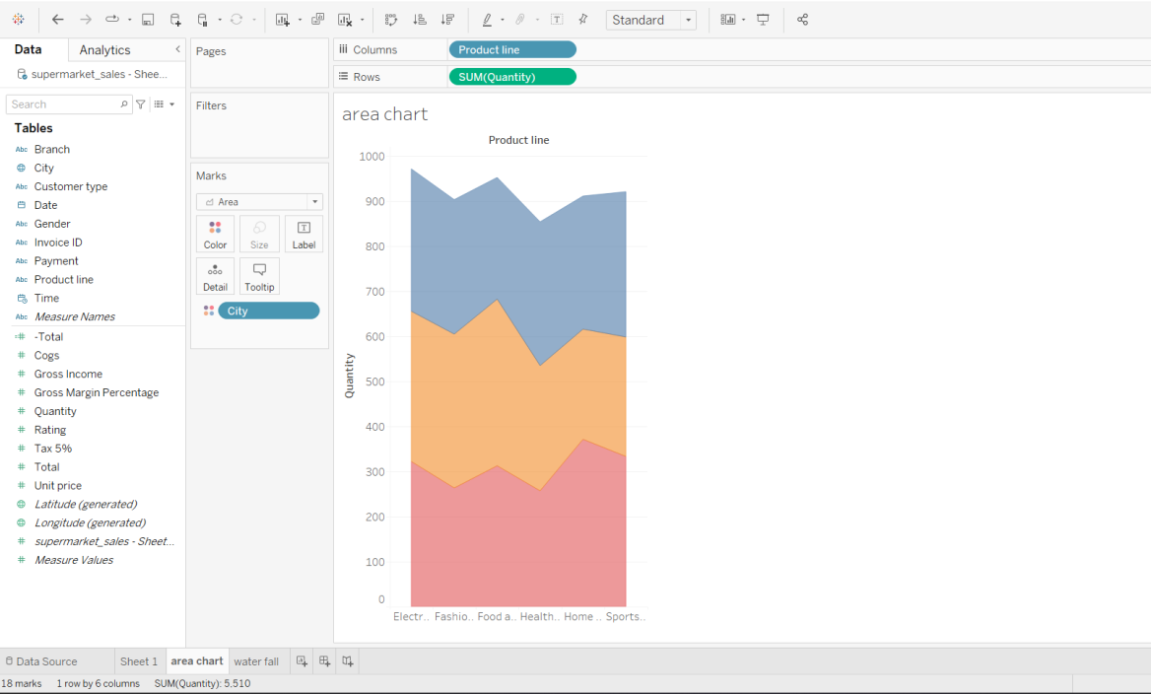

● Text table

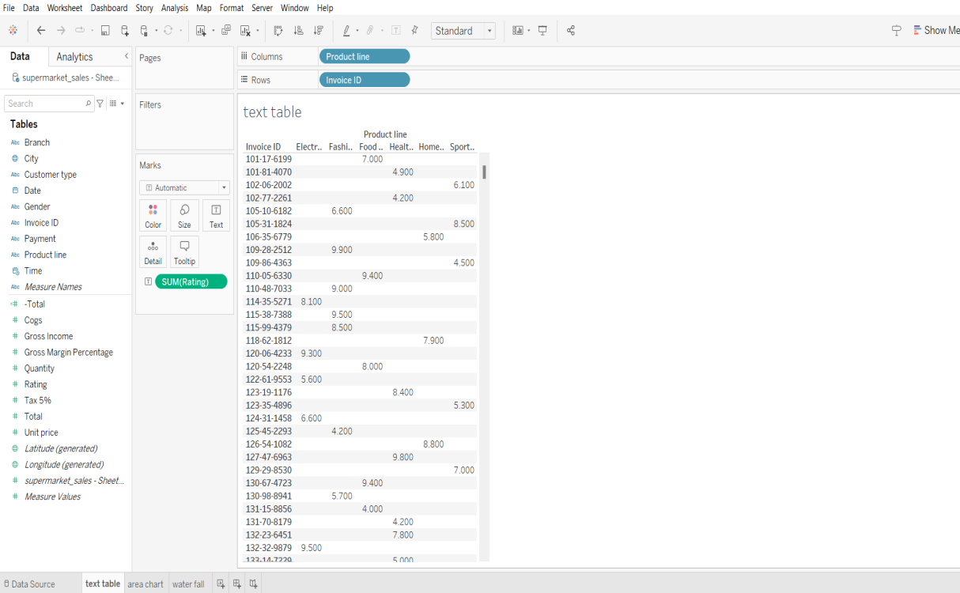

● Highlighted table

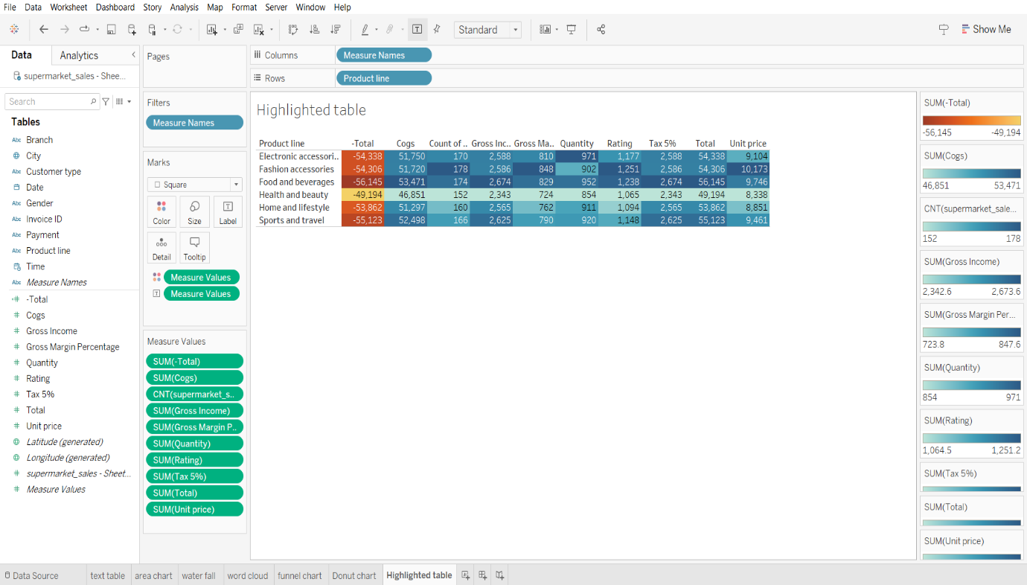

● WordCloud

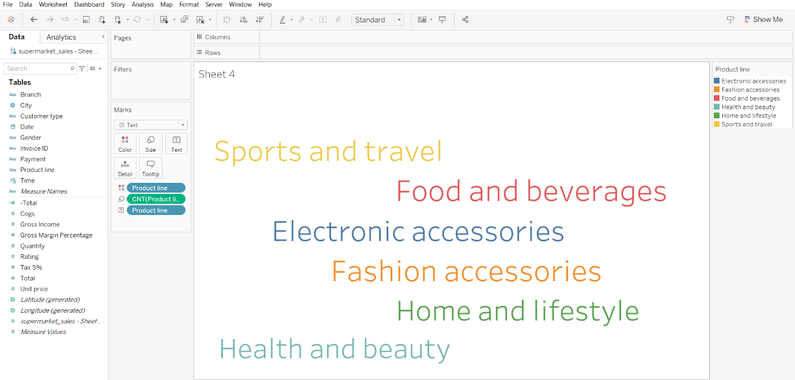

● Funnel Chart

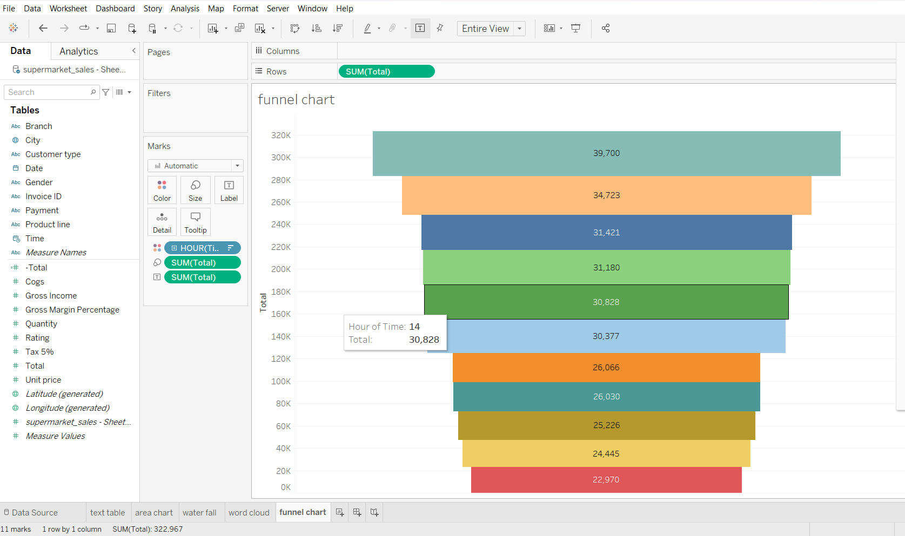

● Waterfall

